The Supplemental Spinner Official Documentation

Steven Wilson

Mt. San Jacinto College

Author Note

To the Supplemental Instruction team of Mt. San Jacinto College, Thank you.

Abstract

This documentation contains every resource used to create “The Supplemental Spinner”. It will go in depth of the CAD (computer assisted design) framework, electrical components, safety measurements, and program. This documentation does not cover activities that can be used while the device is operating, but will give insight to how expandable the device is. Links found throughout this report will redirect readers to GitHub where code can be accessed. Overall, any student, faculty, or person may potentially recreate this device by following the information found in this documentation.

The Supplemental Spinner Official Documentation

Use this device to break the ice. The Supplemental Spinner (**TSS**) is an electrical device that operates on the rules set by an SI Leader. Formally known as The Syllabus Spinner ( <https://github.com/MinicomSoftware/SyllabusSpinner> ), TSS is a stronger and more durable version of this prototype. Intended for SI Leaders to use throughout Mt. San Jacinto College (**MSJC**), TSS has been built to last over 5 years in modern conditions.

# The Components

TSS consists of 29 plastic PLA parts (12 solid plastic pieces and 17 LED caps), and also contains many electrical and physical components.

All Pieces (including electrical pieces) Spring 2018: Amount:

1. Arduino MEGA R3 2560 ……………………………………………………..… 1
2. Male DC 12V Power Supply Plug Adapter Connector………………………….. 1
3. Female DC 12V Power Supply Plug Adapter Connector……………………….. 1
4. 9V Power Cable…………………………………………………………………..1
5. 1/4W 0.25W 5% 220 R OHM Carbon Film Resistor……………………………16
6. Wire jumper cable 20cm 2.54MM male to male…………………………………1
7. B10K 10K Ohm Adjustment Single Linear Rotary Potentiometer……………….1
8. #8-32 x ½ in. Machine Screw……………………………………………………10
9. #8-32 x 1 ½ in. Machine Screw…………………………………………………. 3
10. Wire jumper cable 20cm 2.54MM male to female………………………………18
11. Heavy Duty Toggle Switch - SPST On/Off Type…………………………………1
12. 24mm Push Buttons RED Arcade button………………………………………….1
13. Polyethylene tubing ¼ in. x 25 in…………………………………………………1
14. Black 12 gauge 210V wire (roughly 12 inches)………………………….……….1
15. Red 12 gauge 210V wire (roughly 12 inches)…………………………………….1
16. CREATOLOGY foam surface (4 in x 4in)……………………………………….4
17. Air and moisture filter…………………………………………………………….1
18. Gardner Bender LTB-400 Liquid Electrical Tape Waterproof…………………….1
19. WINGONEER DC 5V Brushless CPU Cooling Fan……………………...………1
20. Gorilla 3023003 Hot Glue………………………………………………..……….1
21. Black PLA filament 1.75mm Accuracy +/- 0.03mm………………………….…..1
22. Silver SainSmart PLA filament 1.75mm Accuracy +/- 0.03mm………………….1
23. Red PLA filament 1.75mm Accuracy +/- 0.03mm……….………………….……1
24. White PLA filament 1.75mm Accuracy +/- 0.03mm…………………….………..1
25. CanonInk Photo Paper Plus Glossy II 8.5" x 11"…………………………………1
26. Chanzon 5mm White LED Diode Lights (Clear Round Transparent DC 3V 20mA)……………………………………………………………………………15
27. Chanzon 5mm Gold LED Diode Lights (Clear Round Transparent DC 3V 20mA)……………………………………………………………………………1
28. Chanzon 5mm Green LED Diode Lights (Clear Round Transparent DC 3V 20mA)……………………………………………………………………………1
29. EVERBILT Machine Screw Nuts #8-32…………………………………………5
30. Vastar 454G Activity Wire Solder 60/40 0.8mm…………………………………1

**The Framework**

CAD software, OnShape, was used to design the framework of TSS.

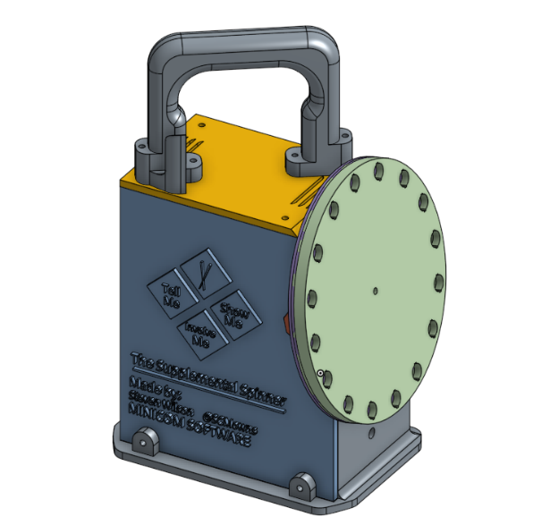Preview of the assembled TSS in 3D. Design work of this model consisted of 10-13 hours. *Note: Not all features made it to the official TSS due to technical difficulties or cold weather conflicts.*

[Check blueprint file included in folder for part details and measurements]. Most parts printed at 100% Fill (solid piece) and 0.06 - 0.25 layer height (detail).

Part Print Details:

|  |  |  |  |  |
| --- | --- | --- | --- | --- |
| Column Head | Color PLA | Fill Density | Layer Height | Print Time |
| BASE V3 | Silver | 100% | 0.15 | 15 HR |
| LED Face | White | 50% | 0.06 | 7 HR |
| LED Cap | White | 80% | 0.06 | 15 Min |
| LED F. Mount | White | 100% | 0.15 | 3 HR |
| Power Wall V4 | Silver | 100% | 0.1 | 5 HR |
| Left Wall | Silver | 100% | 0.06 | 7 HR |
| Controller V2 | Black | 100% | 0.06 | 4 HR |
| Top V2 | Silver | 100% | 0.1 | 3 HR |
| Handle | Silver | 100% | 0.06 | 8 HR |
| Corner Piece | Red | 100% | 0.1 | 30 Min |
| Fan Attachment | Red | 100% | 0.1 | 20 Min |
| Walls Attachment | Red | 100% | 0.06 | 25 Min |

**The Program**

This device’s program is open source. All current code can be found by visiting the URL: <https://github.com/MinicomSoftware/TheSupplementalSpinner> or by scanning this QR code:

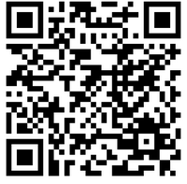

This program shall remain free to access online on GitHub. If SI of MSJC wishes to keep documentation private, then accessing the code will be unavailable to students, faculty, and people online.

Built in fan functionality: The fan turns on the moment the Arduino reaches the green light procedure. The fan will remain on silently for as long as the device is on.

**Designs**

All design work can be accessed through the GitHub repository above under “assets”. The final page of this documentation contains a sample preview of the designs used. All designs, except for the tornado image, are made by Steven Wilson and cannot be sold or used for commercial gains (since this device is solely for educational purposes). The tornado image contains the license: Attribution-NonCommercial 4.0 International (CC BY-NC 4.0) by artist/compiler: Greasiggy_the_Koopa.

Attribution-NonCommercial 4.0 International (CC BY-NC 4.0) license: 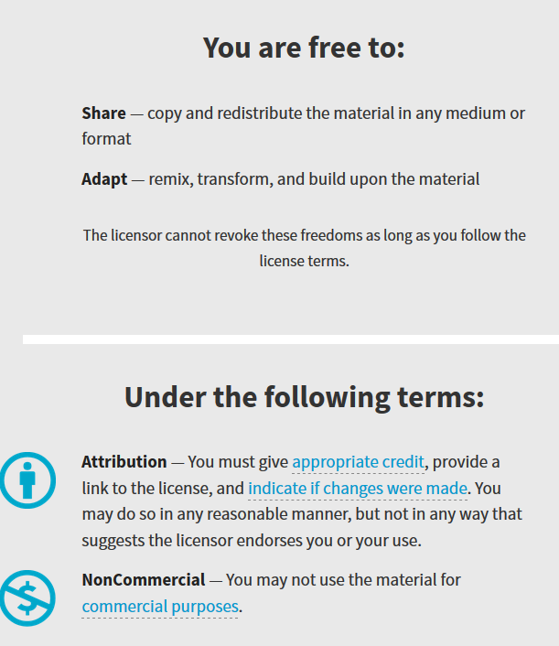

If a request to change any design is needed, contact Steven Wilson. Steven can contact artists and commission for custom designs without licenses.

**Questions and Answers:**

What if I plug a power cable higher than the 12V adaptor?

The current power adaptor can manage from 12V and below and has an insert diameter to manage low DC power plugs. If in the event of a higher voltage power is used, then the Arduino may reject the connection and not work as intended (little heating but not serious as built-in fan will turn ON). If a power supply is connected with opposite polarity (positive and negative are inverted) Arduino has polarity protection diodes (to avoid destroying the board if a Negative Tip adapter was inserted). The game will not turn on with opposite polarity power cords, so use the provided power cord.

Who owns The Supplemental Spinner or has the legal rights to it?

Supplemental Instruction of Mt. San Jacinto College

Can this device be used for commercial gains or profit?

This device adheres to the same rules and regulations that are found in the Supplemental Instruction contact, so no.

What if water reaches the inside of the device?

To begin, drops of water will be filtered through the 3-layer black dust and moister filter found on top of the device. If a cup of water is spilt on top of the device greater than what the filter can manage, then the device may receive water damage if the protective coating of “Gardner Bender LTB-400 Liquid Electrical Tape” fails to protect it. Contact Steven Wilson or an electrical engineer to work around water damaged devices. Do not use the device if reports of water damage are known.

What if this device is dropped?

The durability of this device is listed above under “Part Print Details” > “Fill Density”. The higher the density the more solid the part. If TSS lands on its bottom, then Steven predicts it will have minor scratches/damages. If TSS lands on the LED face, then some LEDs will be pushed inward and replacement might be needed. If the device chipped and a sharp edge is exposed that can encounter a student then this device can no longer be operated until replacements are made.

Can this device shock anyone?

This device contains no exposing wires and the on/off switch is separate from where current is flowing, so no. The red user button is protected with a plastic shell, so that too cannot shock anyone.

What is the risk of a fire occurring?

The device does not contain any flammable material inside, so a fire is impossible to start and to maintain itself. If in the event of severe water damage, then the Arduino board may heat up to a boiling temperature, but not melt through the plastic frame surrounding it (The device will not turn on if this occurs, and no LED will function). Regardless of the condition, this device is made so nothing from the inside can escape to the outside environment.

What if an LED light does not turn on?

The LED light gave out after extensive use; replacement is needed.

Can this device cause a photosensitivity seizure?

The speed of the lights has been upgraded to contain 6 levels of speeds. An SI Leader or person cannot increase the speed to a seizure inducing speed (between 3-30 hertz). Safety precautions should be taken before using this device by asking students if there exists any issues with tolerance to light.

What if the LED cap is pushed inward?

A student or leader must have forced the LED inward. The LED does not retract inward. Steps to fixing the LED cap:

1. Remove The Supplemental Spinner front logo.

2. Remove the screw on the center of the board and top corner (the correction screw)

3. Gently pull the LED face plate toward you and do not disconnect any wires.

4. Locate the LED cap that was damaged and push it outward. If the LED cap is severely damaged, then replace it with a new cap. (Contact Steven Wilson for a replacement file to print (see print details above) or piece).

**Expansion:**

To expand the capability of this device one must be knowledgeable in:

1. Electrical engineering (volts, DC, Switches, wiring and soldering, protecting components, etc.)

2. CAD engineering (measurements, design, physics, etc)

3. programming C++ (how to read and interpret existing code; basic level 1 knowledge)

4. the Arduino fundamentals (pins and inner libraries of the board)

If you do not contain any of these requirements, Steven highly recommends not touching or opening this device.

Potential upgrade location:

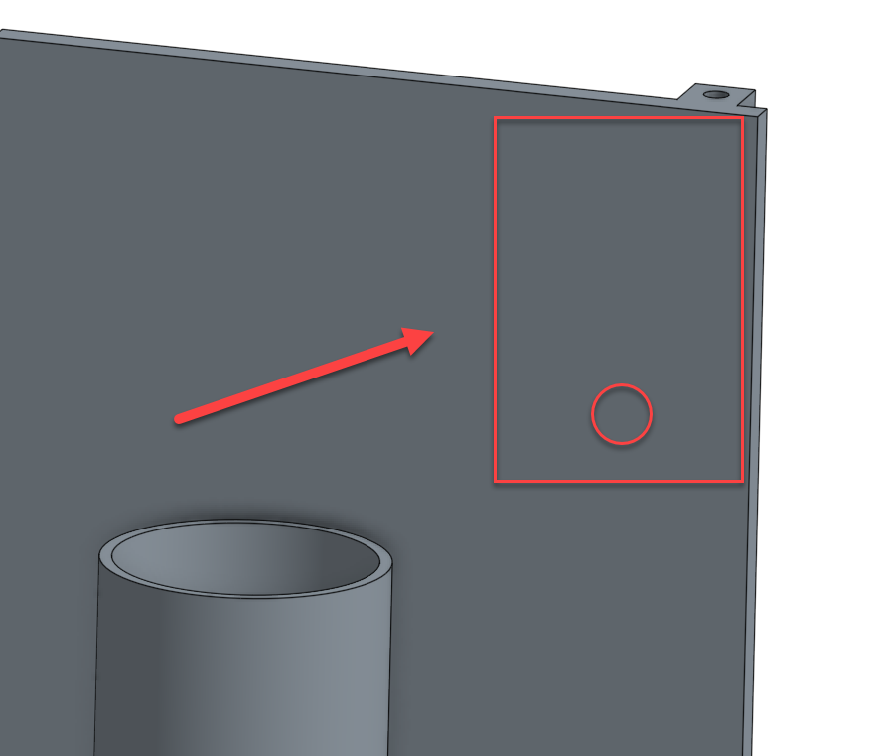

On BASE V3 a hole can be drilled, and a box can be mounted in this general area next to the controller slot. This box can contain switches for potential upgrades like: music [if music component is added], randomizer of the golden light [if lights are modified], and more.

PINS best suited for upgrades: PIN 2, 3, 4 ,5 ,6 7. Follow the next section, **Opening the Device**, to learn about how to properly open this device for upgrades/modifications.

**Opening the Device and Closing**

One must adhere to the same knowledgeable expectations that are listed in the previous section **Expansion** before attempting to open this device. Here are the steps to opening the device properly:

1. Ensure the device is powered OFF

2. Remove the screws from the TOP ROOF V2. (One screw might be extremely tight—it contains powerful adhesive. Try to work gently with the adhesive screw)

3. Once the TOP ROOF V2 contains no screws, gently lift top (beware of fan wires that do not disconnect from the TOP ROOF V2. Place TOP ROOF V2 in a location where the fan wires do not have any tension)

4. Unscrew the LEFT DOOR (ensure the screw connecting the LEFT DOOR to the LIGHT LED FACE is also removed)

5. Rest the LIGHT LED FACE gently towards the right door. It should naturally move towards that direction.

6. With the TOP ROOF V2 and the LEFT DOOR removed the device is now considered “opened”.

7. For any updates to the program the BACK POWER DOOR V4 must be removed. This door contains powerful EPOXY adhesive on the top corner. Use a box cutter to remove adhesive. This process may take a while.

8. To assemble the device together one must follow the same steps but backwards. Apply recommended adhesive: White Gorilla Glue Pen Adhesive or Gorilla EPOXY Clear—to top corner location of the BACK POWER DOOR V4 and during the mounting of the TOP ROOF V2 (The extremely tight screw from before (step 2)).

**Contact Details**

Inventor:

Steven Wilson Phone: **Ask Coordinator.**

Email: [scmowns@yahoo.com](mailto:scmowns@yahoo.com) Alt. Email: scmowns@gmail.com

References

Onshape: Modern CAD. Finally. (n.d.). Retrieved January 10, 2018, from http://www.onshape.com/

WHAT IS ARDUINO? (n.d.). Retrieved January 10, 2018, from <https://www.arduino.cc/>

Wilson, S. (2018, January 08). Minicom Software. Retrieved January 10, 2018, from <https://github.com/MinicomSoftware/TheSupplementalSpinner>

Franco, U. W. (2017, December 21). Un wn llamado Franco “Greasiggy_the_Koopa” (@MadMegalomania). Retrieved January 12, 2018, from https://twitter.com/MadMegalomania